General Questions on Test Topics

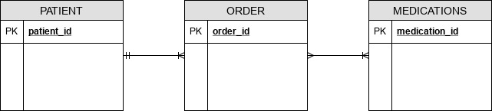
1. What are the applications to which a weak entity may be applied? Other than a bridge entity, when else could it be needed? Part b) When to use a bridge table that doesn’t make use of the composite keys?

E.g. Patient/Medication relationship is split up using the Order entity, which has Order_ID. But, Enroll entity in another example (Student/Classes) uses a composite key

2. When to create a new attribute for an existing entity versus creating a separate/new entity? Is this just a decision of the designer? If so, then what are the guiding principles for that decision.

3. What are the uses and needs of recursive relationships, e.g. the EMPLOYEE/MANAGER one or COURSE/CLASS or others that generally have the same optional element from #2 about either breaking out new entities or including the attributes in a single table for recursive as well?

E.g. specifically what is a 1:1 recursive relationship (is there another example of how it works?)

4. Are these topics not the focus on the Exam...constraints, relational operators like JOIN,PRODUCT, and non-relational Databases (e.g. Hadoop, Distributed, or Cloud platforms)?

